 |  | Horton in  Ribblesdale  St Oswald’s CE |  | 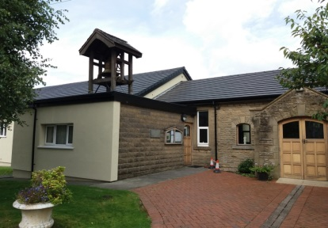  Settle  St Mary’s and  St Michael’s  Catholic Church  Tilman Close |  |  | 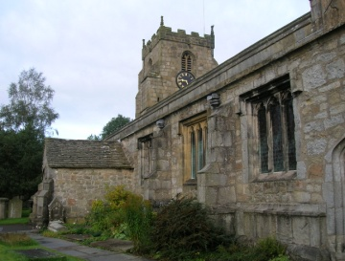  Giggleswick  St Alkelda’s CE
 | Stainforth  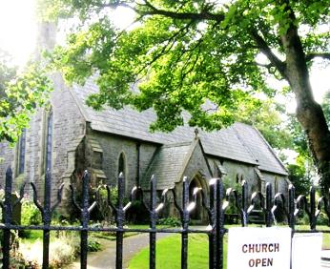  St Peter’s CE |  |  | Welcome  to our churches  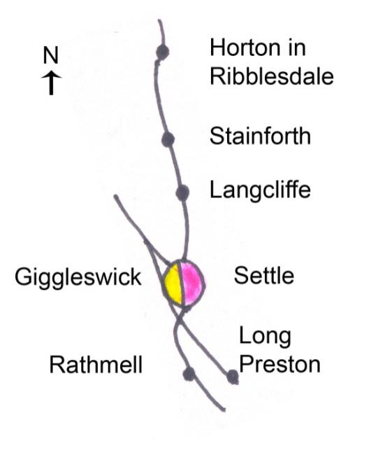 |  |  | 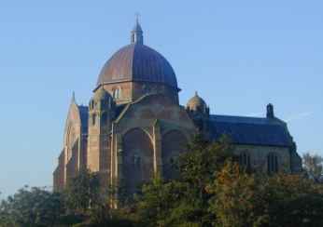  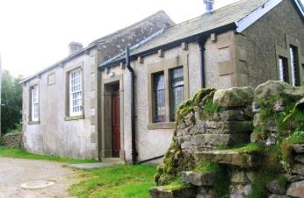 | Giggleswick School  Chapel
 |  | Langcliffe  St John the  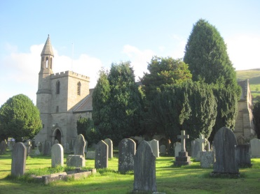  Evangelist CE |  |  |  |  | Rathmell  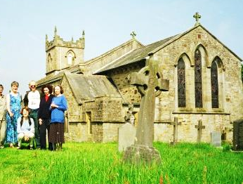  Methodist
 | Settle  Holy Ascension CE  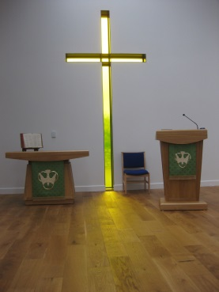  Church Street |  |  | 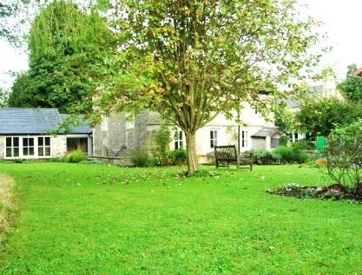 |  |  |  | Rathmell  Holy Trinity CE
 |  | Settle  St John’s Methodist  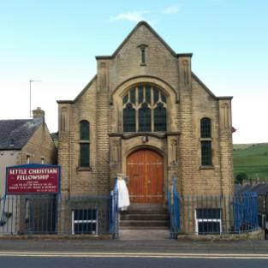  Off Church Street |  |  | Settle  Friends Meeting  House, Kirkgate  Settle |  | Long Preston  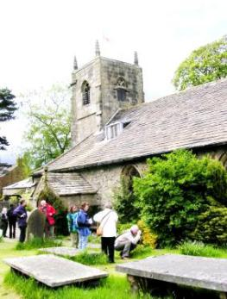  Methodist
 | Settle  Christian Fellowship  Duke Street |  |  | St Aiden’s, Hellifield | 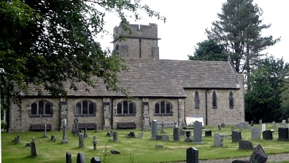 |  |  | Long Preston  St Mary’s CE

 | Catholic Church, Tillman Close, Settle (01729 822525)  Masses:  Saturday (Sun Vigil) 6 pm  Sunday 11.15 am  Tuesday 10 am  Thursday 10 am  Friday 10 am  Settle Christian Fellowship, Duke Street, Settle (01729 823046, 07900210001)  Sunday 10.45am Praise & message, with Communion weekly  Wed 7.30pm Bible Study. Phone for more info  Settle Society of Friends (Quakers) – Kirkgate, (01729 822313)  Meeting for Worship (with  children’s meeting)  Sunday 10.30 a.m.  Tuesday 12.15 – 12.45  Meeting for Worship  Traidcraft shop + coffee  Friends Meeting House  Tuesday 10am-12noon  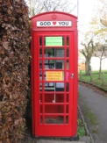  Churches  Together  in Settle & District  God  Loves  You  Telephone  Box near  Cenotaph, Church St  Settle | Settle Parish Church, Church Street, (01729 824191) -  2nd 3rd 4th Suns: 10am  1st & 5th Sun check noticeboard or website  Settlechurch.org.uk The 10am Joint service may be elsewhere.  Tue 9.30 am Holy Communion (1/2 hour)  Tue 10am-midday Coffee; Lunches in Summer, Soup in Winter.12.00-1.30  Giggleswick Parish Church (01729 824191) 5th Sun: See noticeboard. Rotates  2nd 3rd 4th Suns: 10am  1st & 5th Sun check noticeboard or website  Gigglewickchurch.org.uk The 10am Joint service may be elsewhere  Rathmell Parish Church (01729 824191)  2nd 3rd 4th Suns: 10am  1st & 5th Sun check noticeboard or website  Rathmellchurch.org.uk The 10am Joint service may be elsewhere |  | Settle Methodist Church, Church Street, Settle (01729 822554)  Sunday 10.30am  Occasional afternoon 4.pm and evening 6.30pm services - See notice board  Tue 10 – 12am Coffee Morning.  Tues pm: House group Bible Study. Phone for details.  1st Thurs: Women’s Thursday Group  Rathmell Methodist Church (01729 840520)  Sunday 2.00 pm except 2nd Sunday of month then 10.30am.  2nd Tuesday of month (Not in summer): Guild (with speakers) 01729 823265 or 840520  Long Preston Methodist Church (01729 850894)  Sun 11.00 am Service  Long Preston Parish Church (01729 851511)  Every Sun 11.00 am Morning Worship  Langcliffe  Horton in Ribblesdale Stainforth  (Upper Ribblesdale Parish Churches )  (07977141869):-  See church notice boards  Giggleswick School Chapel.  01729 893000/893190 | CHURCHES TOGETHER MEETINGS:  Messy Church – for  children (aged 0-100) & families-  Activities, celebration and a meal.  June is usually an outing. More info on dates and location:  Check www.ctisad.org.uk  01729 825285  Prayer Meetings- CTISAD 1st Mon 7.30 pm Settle Parish Church.  Persecuted Church  2nd Mon 7.30pm. Rotates. for both check 01729 825869  Justice and Peace  Group – 2nd Weds 7.30pm Friends Meeting House  Songs of Praise in  Limestone View lounge  3rd Thurs 6.30 – 7.15pm  Residents of this area; Holiday makers; Visitors:  ALL WELCOME  © J Allinson 2018 |  | Church Service  Times  in Settle and District  .  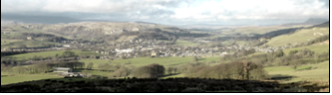  Settle, Giggleswick, Langcliffe,  Horton in Rib, Stainforth, Long Preston, Rathmell, Hellifield 2018  www.ctisad.org.uk  ctisad stands for Churches Together in Settle and District  The website has links to the churches’ websites  and their email addresses  Picture above: Settle, taken from Cleatop Wood

