 |  | Horton in  Ribblesdale  St Oswald’s CE |  | 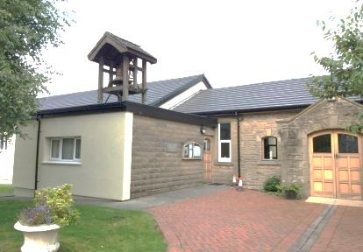  Settle  St Mary’s and  St Michael’s  Catholic Church  Tilman Close |  |  | 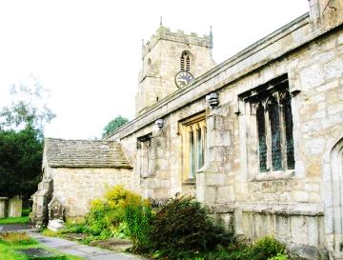  Giggleswick  St Alkelda’s CE
 | Stainforth  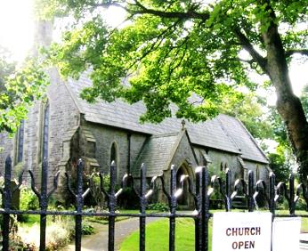  St Peter’s CE |  |  | Welcome  to our churches  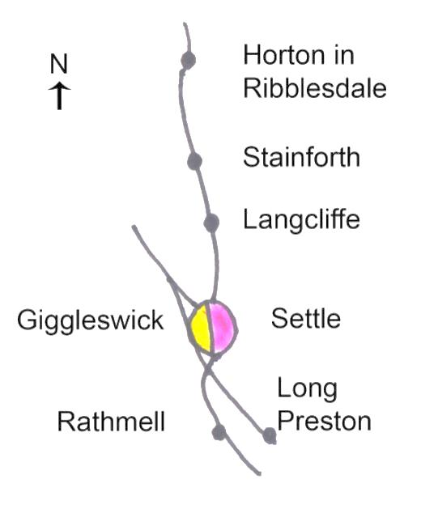 |  |  | 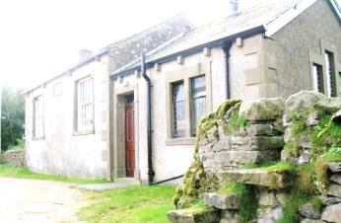 | Giggleswick School  Chapel
 |  | Langcliffe  St John the  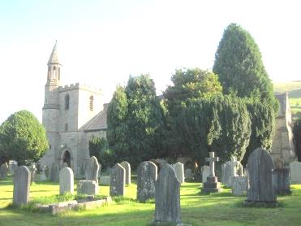  Evangelist CE |  |  |  |  | Rathmell  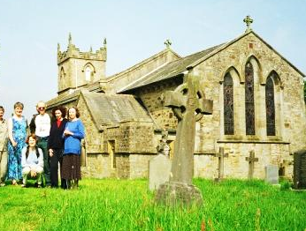  Methodist
 | Settle  Holy Ascension CE  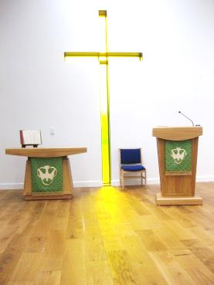  Church Street |  |  | 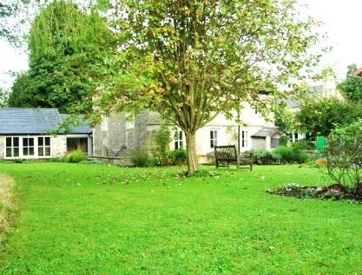 |  |  |  | Rathmell  Holy Trinity CE
 |  | Settle  St John’s Methodist  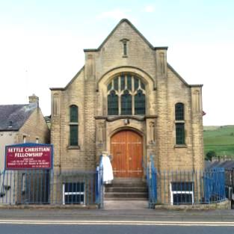  Off Church Street |  |  | Settle  Friends Meeting  House, Kirkgate  Settle |  | Long Preston  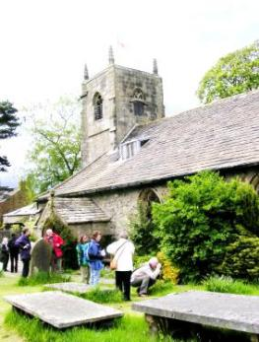  Methodist
 | Settle  Christian Fellowship  Duke Street |  |  | St Aiden’s, Hellifield | 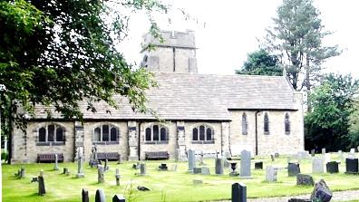 |  |  | Long Preston  St Mary’s CE

 | Catholic Church, Tillman Close, Settle (01729 822525)  Masses:  Saturday (Sun Vigil) 6 pm  Sunday 11.15 am  Tuesday 10 am  Thursday 10 am  Friday 10 am  Settle Christian Fellowship, Duke Street, Settle (01729 823046, 07900210001)  Sunday 10.45am Praise & message, with Communion weekly  Wed 7.30pm Bible Study. Phone for more info  Settle Society of Friends (Quakers) – Kirkgate, (01729 822313)  Meeting for Worship (with  children’s meeting)  Sunday 10.30 a.m.  Tuesday 12.15 – 12.45  Meeting for Worship  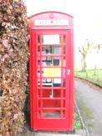  Churches  Together  in Settle & District  God  Loves  You  Telephone  Box near  Cenotaph, Church St  Settle | For Anglican Churches please also check their websites.  Links available from www.ctisad.org.uk  Settle Parish Church, Church Street, (01729 824191) -  2nd 3rd 4th Suns: 10am  1st & 5th Sun check noticeboard or website  The 10am Joint service may be elsewhere.  Tue 9.30 am Holy Communion (1/2 hour)  Tue 10am-midday Coffee; Lunches in Summer, Soup in Winter.12.00-1.30  Giggleswick Parish Church (01729 824191) 5th Sun: See noticeboard. Rotates  2nd 3rd 4th Suns: 10am  1st & 5th Sun check noticeboard or website  The 10am Joint service may be elsewhere  Rathmell Parish Church (01729 824191)  2nd 3rd 4th Suns: 10am  1st & 5th Sun check noticeboard or website  The 10am Joint service may be elsewhere  Hellifield Parish Church 01729 851511  Usually 9.30am Holy Communion but check hellifieldparishchurch.blogspot.com/ |  | Settle Methodist Church, Church Street, Settle (01729 822554)  Sunday 10.30am  Occasional evening 6.30pm services - See notice board  Tue 10 – 12am Coffee Morning.  Tues pm: House group Bible Study. Phone for details.  1st Thurs: Women’s Thursday Group  Rathmell Methodist Church (01729 840520)  Sunday 2.00 pm except 2nd Sunday of month then 10.30am.  2nd Tuesday of month (Not in summer): Guild (with speakers) 01729 823265 or 840520  Long Preston Methodist Church (01729 850894)  Sun 11.00 am Service  Long Preston Parish Church (01729 851511)  Every Sun 11.00 am Morning Worship  Langcliffe  Horton in Ribblesdale Stainforth  (Upper Ribblesdale Parish Churches )  (07977141869):-  See church notice boards  Giggleswick School Chapel.  01729 893000/893190 | CHURCHES TOGETHER MEETINGS:  Messy Church – for  children (aged 0-100) & families-  Activities, celebration and a meal.  Ask for details  Check www.ctisad.org.uk  01729 825285  Prayer Meetings- CTISAD 1st Mon 7.30 pm Settle Parish Church.  Persecuted Church  2nd Mon 7.30pm. Rotates. for both check 01729 825869  Justice and Peace  Group – 2nd Weds 7.30pm Friends Meeting House justicepeacesettle.wordpress.com/  Songs of Praise in  Limestone View lounge  3rd Thurs 6.30 – 7.15pm  Residents of this area; Holiday makers; Visitors:  ALL WELCOME  © J Allinson 2019 |  | Church Service  Times  in Settle and District  .  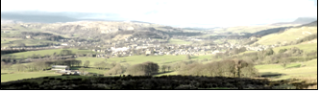  Churches  Together  In  Settle  And  District  Settle, Giggleswick, Langcliffe,  Horton in Rib, Stainforth, Long Preston, Rathmell, Hellifield 2019  ctisad.org.uk  provides links to individual  church websites  and news of CTISAD events  Picture above: Settle, taken from Cleatop Wood

