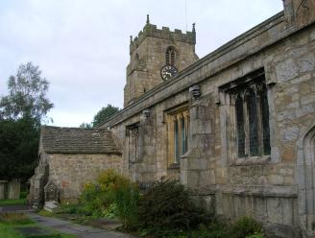
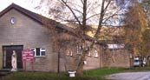

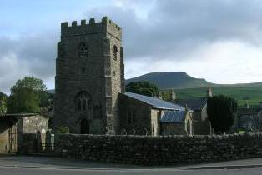

 |  | Horton in  Ribblesdale  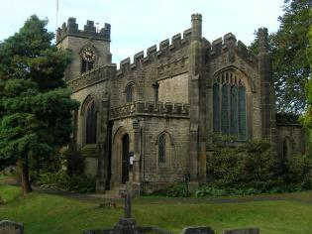  St Oswald’s |  | Settle  St Mary’s and  St Michael’s  Catholic Church |  |  | Gigglesick  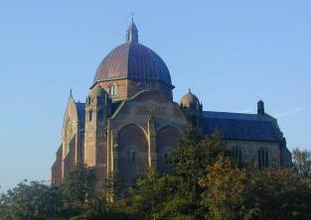  St Alkelda CE
 | Stainforth  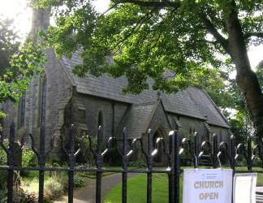  St Peter’s |  |  | Welcome  to our churches  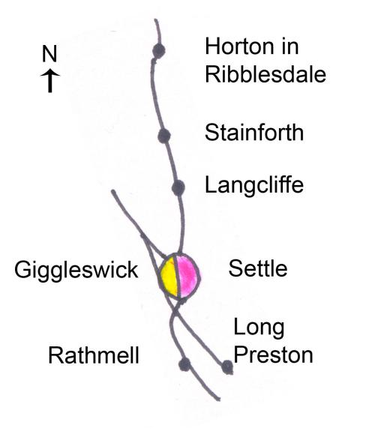 |  |  |  | Giggleswick School  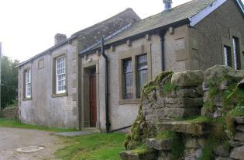  Chapel
 | 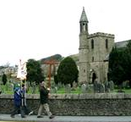 | Langcliffe  St John the  Evangelist CE |  |  |  |  | Rathmell  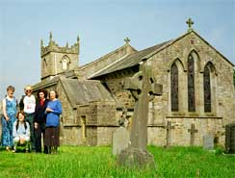  Methodist
 | Settle  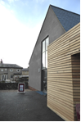  Holy Ascension CE |  |  |  |  |  |  | Rathmell  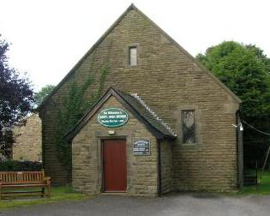  Holy Trinity CE
 |  | Settle  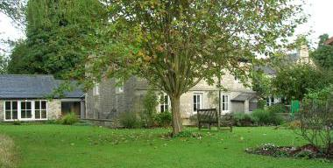  St John’s Methodist |  | 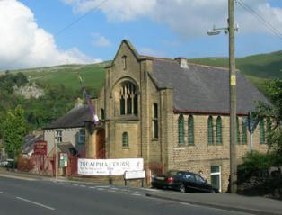 |  |  | Long Preston  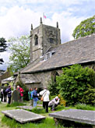  Methodist
 | Settle  Friends Meeting  House |  |  | Settle  Christian Fellowship |  |  |  | Long Preston  St Mary’s CE

Joint Churches Together Meetings:  Messy Church – for families- Most 3rd Sundays – 3.30-5.30pm St John’s Ch Hall, Settle (not Jan, or Aug)  Limsetone View: Songs of Praise: 3rd Thurs evening of month:  Anley Hall Nursing Home, Skipton Road  Last Sun / month 2.30pm – Praise Service  Phone 01729 822138 if you’d like a lift tothis event  1st Wed / month Holy Communion. 2.00pm -01729 823380  Meetings  Justice and Peace  Group – 2nd Weds 7.30pm Friends Meeting House  Prayer Meetings- For CTISAD 1st Mon 7.30 ^{pm}  Settle Parish Church.  For Persecuted Church  2nd Mon 7.30pm. 10, Townhead Ave. for both check 01729 822311  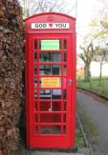  Churches Together in Settle “God Loves You” Telephone Box (near the cenotaph) | Individual Churches  Settle Society of Friends (Quakers) – Kirkgate, (01729 822313)  Meeting for Worship (with children’s meeting) Sunday 10.30 a.m.  Tuesday 12.15 – 12.45 Meeting for Worship  Traidcraft shop + coffee  Friends Meeting House  Tuesday 10am-12:  Settle Parish Church, Church St (01729 824191)  Main Service every Sun: 9.30am 1st 3rd 4th 5th Suns 9.30 am: Parish Communion  2nd Sun 9.30am Family Worship;  2nd Sun 8.00am  Holy Communion  Tue 9.30 am Holy Communion (1/2 hour)  Tue 10am-midday Coffee; Lunches in Summer.  Mon-Sat 8.00am  Morning Prayer  Long Preston Parish Church (01729 851511)  Every Sun 11.00 am Morning Worship  Long Preston Methodist Church (01729 850894)  Sun 11.00 am  Giggleswick School Chapel.01729 893000/893190 |  | Giggleswick Parish Church (01729 824191)  Main service every Sun: 11am  Every Sunday 8 am except 2nd Sun  BCP Holy Communion  1st Sun 11.00a.m All Age Communion (CW)  2nd.3rd.5th Sun 11.00am Parish Communion CW  4th Sun Morning Prayer  Every Sun 4.30pm Informal Worship  4th Sun 6pm Sung Evensong  Wed 9.30am Communion  Mon-Sat 5.15pm Evening Prayer  Rathmell Parish Church (01729 824191)  2nd Sun 9.30am Family Service with Rathmell Primary School  4th Sun 11.00 am Parish Communion  Rathmell Methodist Church (01729 840520)  Sunday 2.00 pm except 2nd Sun-then 10.30am.  2nd Tue of month (Not in summer): Guild (with speakers) 01729 823265 or 840520  Tues 4.30-5.30pm  Langcliffe Parish Church (07977141869)  See church notice board  Stainforth Parish Church (07977141869)  See church notice board | Horton in Ribblesdale Parish Church (07977141869)  See church notice board  Catholic Church, Tillman lose, Settle (01729 822525) Masses:  Saturday (Sun Vigil) 6 pm  Sunday 11.15 am  Tuesday 10 am  Thursday 10 am  Friday 10 am  Settle Christian Fellowship, Duke Street, Settle (01729 851332, 07761 678178)  Sunday 10.45am  Wed 7.30pm House group Bible Study. Phone for info  Settle Methodist Church, Church St, Settle (01729 822554)  Sunday 10.30am  Occasional afternoon 4.pm and evening 6.30pm services - See notice board.  Tue 10–12 Coffee Morning.  Weds 7.30pm: House Group Bible Study. Phone for details.  1st Thurs: Women’s Thursday Group  Residents of this area; Holiday makers; Visitors:  ALL WELCOME  © J Allinson 2017  Churches Together in Settle |  | .  Church Services  Settle  in and  District  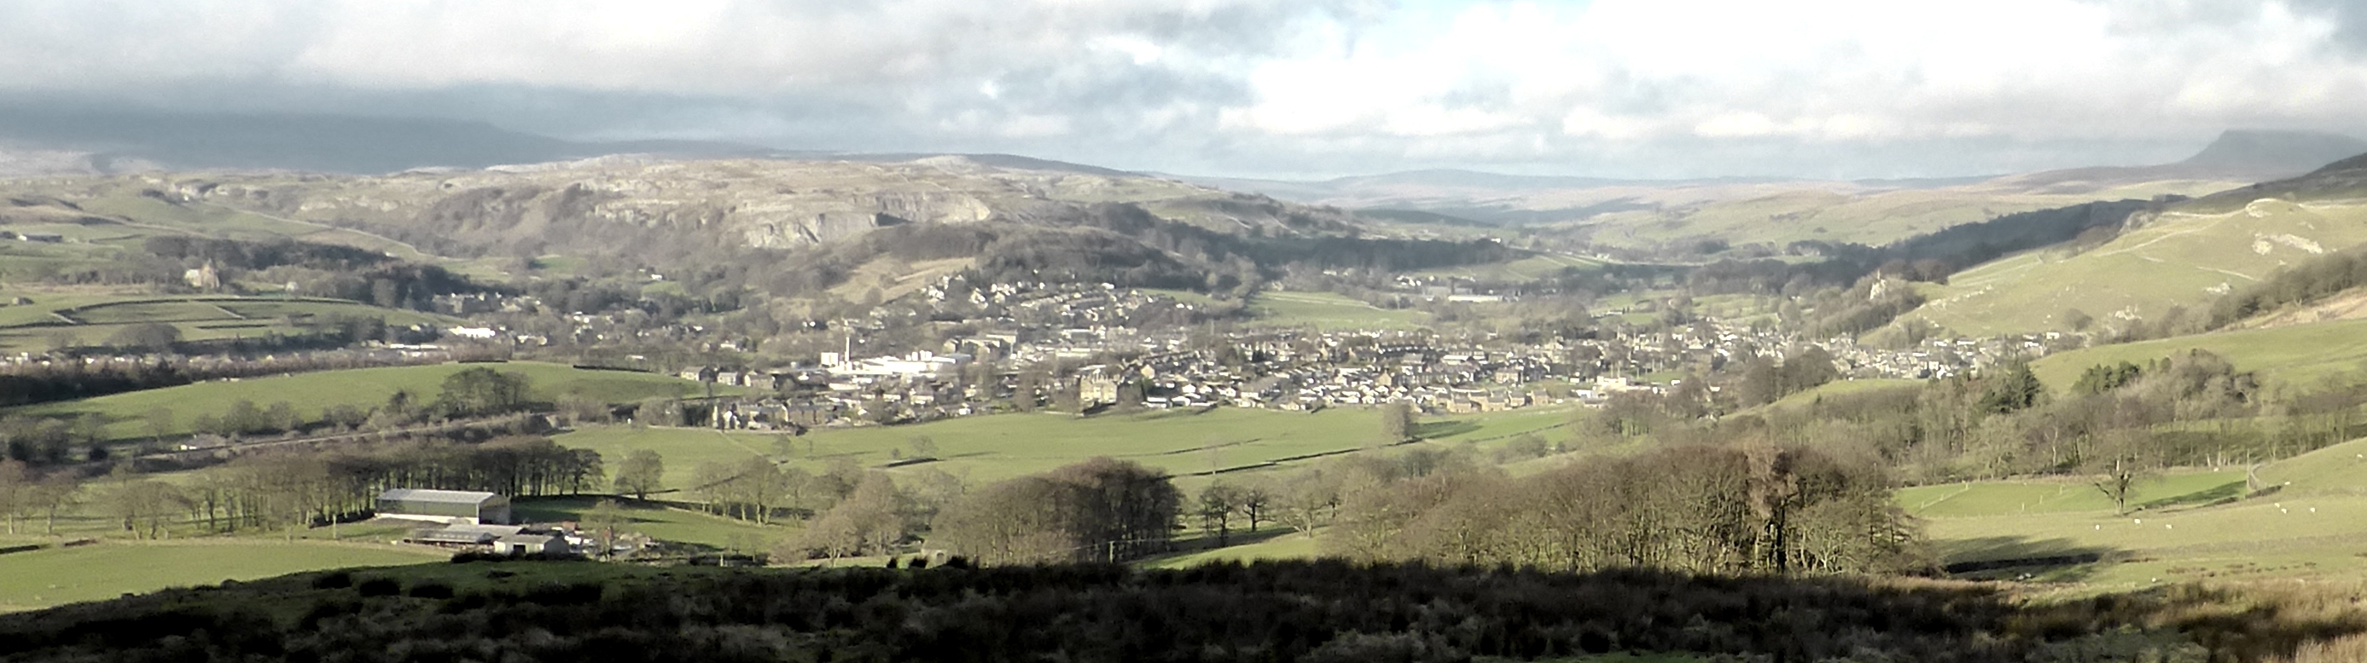  Welcome  and District  Settle,  Giggleswick, Langcliffe,  Horton in Rib, Stainforth, Long Preston, Rathmell 2017  www.ctisad.org.uk  ctisad stands for Churches Together in Settle and District  The website has links to the churches websites  and their email addresses  Picture above: Settle, taken from Cleatop Wood

